**Homework 5 Xiumei Wang284**

rm(list = ls())

install.packages("RCurl")

install.packages("XML")

library(RCurl)

library(XML)

url1 = "http://shakespeare.mit.edu/romeo_juliet/full.html"

url2 = "http://shakespeare.mit.edu/julius_caesar/full.html"

url3 = "http://shakespeare.mit.edu/hamlet/full.html"

html1 = readLines(url1, encoding = "UTF-8")

html2 = readLines(url2, encoding = "UTF-8")

html3 = readLines(url3, encoding = "UTF-8")

html1 = htmlParse(html1, encoding = "UTF-8")

html2 = htmlParse(html2, encoding = "UTF-8")

html3 = htmlParse(html3, encoding = "UTF-8")

install.packages("bitops")

install.packages("stringr")

library(bitops)

library(stringr)

abs1 = lapply(url1, FUN = function(x) htmlParse(x, encoding = "Latin-1"))

abs2 = lapply(url2, FUN = function(x) htmlParse(x, encoding = "Latin-1"))

abs3 = lapply(url3, FUN = function(x) htmlParse(x, encoding = "Latin-1"))

clean_txt = function(x) {

cleantxt = xpathApply(x, "//body//text()

[not(ancestor :: script)][ not(ancestor :: style)]

[not(ancestor :: noscript)] " ,xmlValue)

cleantxt = paste(cleantxt, collapse="\n")

cleantxt = str_replace_all(cleantxt, "\n", " ")

cleantxt = str_replace_all(cleantxt, "\r", "")

cleantxt = str_replace_all(cleantxt, "\t", "")

cleantxt = str_replace_all(cleantxt, "<br>", "")

return(cleantxt)

}

cleantxt1 = lapply(abs1,clean_txt)

cleantxt2 = lapply(abs2,clean_txt)

cleantxt3 = lapply(abs3,clean_txt)

vec_abs1 = unlist(cleantxt1)

vec_abs2 = unlist(cleantxt2)

vec_abs3 = unlist(cleantxt3)

###Text Mining

install.packages("tm")

install.packages("SnowballC")

library(tm)

library(SnowballC)

abs1 = Corpus(VectorSource(vec_abs1))

abs2 = Corpus(VectorSource(vec_abs2))

abs3 = Corpus(VectorSource(vec_abs3))

abs_dtm1 = DocumentTermMatrix(abs1, control = list(

stemming = TRUE, stopwords = TRUE, minWordLength = 3,

removeNumbers = TRUE, removePunctuation = TRUE))

abs_dtm2 = DocumentTermMatrix(abs2, control = list(

stemming = TRUE, stopwords = TRUE, minWordLength = 3,

removeNumbers = TRUE, removePunctuation = TRUE))

abs_dtm3 = DocumentTermMatrix(abs3, control = list(

stemming = TRUE, stopwords = TRUE, minWordLength = 3,

removeNumbers = TRUE, removePunctuation = TRUE))

##WordCloud

instal.packages("ggplot2")

install.packages("wordcloud")

library(ggplot2)

library(wordcloud)

freq1 = colSums(as.matrix(abs_dtm1))

freq2 = colSums(as.matrix(abs_dtm2))

freq3 = colSums(as.matrix(abs_dtm3))

wf1 = data.frame(word=names(freq1), freq=freq1)

wf2 = data.frame(word=names(freq2), freq=freq2)

wf3 = data.frame(word=names(freq3), freq=freq3)

#Romeo and Juliet

plot1 = ggplot(subset(wf1, freq>15), aes(word, freq1))

plot1 = plot1 + geom_bar(stat="identity")

plot1 = plot1 + theme(axis.text.x=element_text(angle=45, hjust=1))

plot1

freq1 = colSums(as.matrix(abs_dtm1))

dark2_1 = brewer.pal(6, "Dark2")

wordcloud(names(freq1), freq1, max.words=100, rot.per=0.2, colors=dark2_1)

#Julius Caeser

plot2 = ggplot(subset(wf2, freq>15), aes(word, freq2))

plot2 = plot2 + geom_bar(stat="identity")

plot2 = plot2 + theme(axis.text.x=element_text(angle=45, hjust=1))

plot2

freq2 = colSums(as.matrix(abs_dtm2))

dark2_2 = brewer.pal(6, "Dark2")

wordcloud(names(freq2), freq2, max.words=100, rot.per=0.2, colors=dark2_2)

#Hamlet

plot3 = ggplot(subset(wf3, freq>15), aes(word, freq3))

plot3 = plot3 + geom_bar(stat="identity")

plot3 = plot3 + theme(axis.text.x=element_text(angle=45, hjust=1))

plot3

freq3 = colSums(as.matrix(abs_dtm3))

dark2_3 = brewer.pal(6, "Dark2")

wordcloud(names(freq3), freq3, max.words=100, rot.per=0.2, colors=dark2_3)

#Romeo and Juliet

plot1 = ggplot(subset(wf1, freq>15), aes(word, freq1))

plot1 = plot1 + geom_bar(stat="identity")

plot1 = plot1 + theme(axis.text.x=element_text(angle=45, hjust=1))

plot1

freq1 = colSums(as.matrix(abs_dtm1))

dark2_1 = brewer.pal(6, "Dark2")

wordcloud(names(freq1), freq1, max.words=100, rot.per=0.2, colors=dark2_1)

#Julius Caeser

plot2 = ggplot(subset(wf2, freq>15), aes(word, freq2))

plot2 = plot2 + geom_bar(stat="identity")

plot2 = plot2 + theme(axis.text.x=element_text(angle=45, hjust=1))

plot2

freq2 = colSums(as.matrix(abs_dtm2))

dark2_2 = brewer.pal(6, "Dark2")

wordcloud(names(freq2), freq2, max.words=100, rot.per=0.2, colors=dark2_2)

#Hamlet

plot3 = ggplot(subset(wf3, freq>15), aes(word, freq3))

plot3 = plot3 + geom_bar(stat="identity")

plot3 = plot3 + theme(axis.text.x=element_text(angle=45, hjust=1))

plot3

freq3 = colSums(as.matrix(abs_dtm3))

dark2_3 = brewer.pal(6, "Dark2")

wordcloud(names(freq3), freq3, max.words=100, rot.per=0.2, colors=dark2_3)

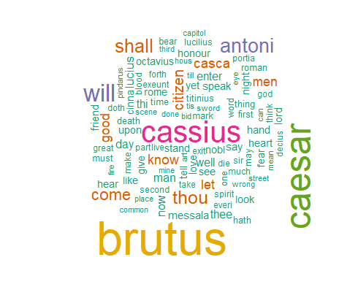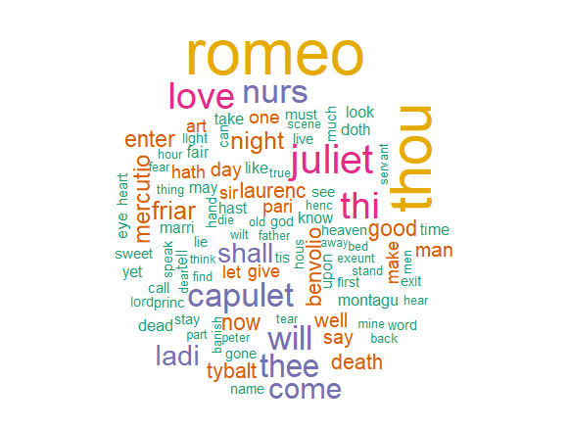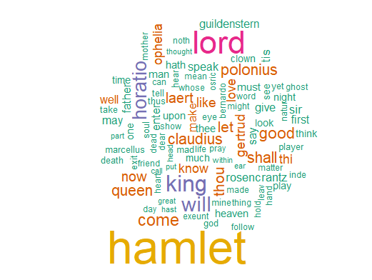

Question 2

#Romeo and Juliet

wf1 <- wf1[order(-wf1$freq),]

wf1 <- wf1[c(1:20),]

p1 = ggplot(subset(wf1, freq > 15), aes(word, freq))

p1 = p1 + geom_bar(stat = "identity")

p1 = p1 + theme(axis.text.x = element_text(angle = 45, hjust = 1))

p1

#Julius Caeser

wf2 <- wf2[order(-wf2$freq),]

wf2 <- wf2[c(1:20),]

p2 = ggplot(subset(wf2, freq > 15), aes(word, freq))

p2 = p2 + geom_bar(stat = "identity")

p2 = p2 + theme(axis.text.x = element_text(angle = 45, hjust = 1))

p2

#Hamlet

wf3 <- wf3[order(-wf3$freq),]

wf3 <- wf3[c(1:20),]

p3 = ggplot(subset(wf3, freq > 15), aes(word, freq))

p3 = p3 + geom_bar(stat = "identity")

p3 = p3 + theme(axis.text.x = element_text(angle = 45, hjust = 1))

p3

